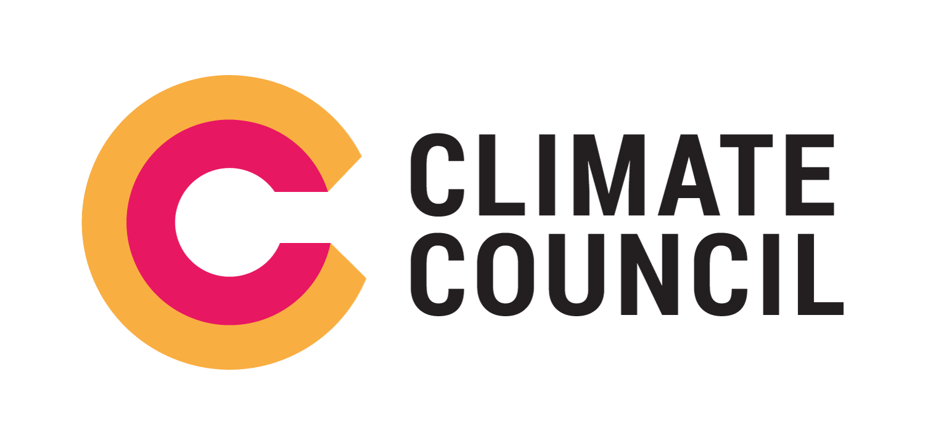
Embargoed until 12:01am, Thursday May 9

Climate Change Could Wipe Billions Off Property Market: New Report

THE VALUE OF Australian property is predicted to fall dramatically unless urgent steps are taken to address climate change, according to a new report from the Climate Council.

“The property market is expected to lose $571 billion in value by 2030 due to climate change and extreme weather, and will continue to lose value in the coming decades if emissions remain high,” said climate risk expert and report author, Dr Karl Mallon.

“This is the largest analysis of property risk from climate change ever undertaken in Australia and uses the latest data from our universities,” he said.

The new report: “Compound Costs” finds that climate change is a major threat to Australia’s financial stability and poses systemic economic risks across the country and the region.

“Some Australians will be catastrophically affected by climate change. Low-lying properties near rivers and coastlines are particularly at risk,” said Dr Mallon.

“Increasingly, Australians are also going to struggle to pay for home insurance. On current trends, by 2030, one in every 19 property owners faces the prospect of insurance premiums that will be effectively unaffordable,” he said.

“Even for Australians who who can afford to pay, general insurance currently does not cover damage from coastal inundation and erosion: events which are likely to become more common because of climate change,” said Dr Mallon.

Other Key Report Findings:

- Climate change is worsening extreme events like heatwaves and floods affecting agriculture and food production; this will cost us much more in future.
- Previous severe droughts have reduced Australia’s Gross Domestic Product by around 1%; estimates suggest that increasing drought frequency and impacts in the future may reduce GDP by 1% every year.
- On current trends, reduced agricultural and labour productivity as a result of climate change is projected to cost Australia $19 billion by 2030 and $211 billion by 2050.
- The Murray-Darling Basin currently produces half of Australia’s irrigated agricultural output, including cotton, rice and dairy. This is worth around $7.2 billion per year. By 2050, the irrigated output in the Basin is projected to halve if emissions remain at high levels.
- By 2090, wheat yields on the 4,200 family farms in WA that produce half of Australia’s wheat are projected to fall by 41-49 percent if greenhouse gas emissions remain high.

“Detailed new modelling, based on Australia’s current approach to climate change, and global trends, finds the economic damage to Australia’s agricultural sector will also be significant,” said report author and University of Melbourne economist, Professor Tom Kompas.

“If emissions were to continue at current levels, cumulative damages to both agriculture and labour productivity over the next 80 years would cost the economy more than $4 trillion. This is not a trivial figure -- it is more than double Australia’s current Gross Domestic Product,” said Professor Kompas.

“Climate change has wide-ranging impacts across the economy. For instance, extreme weather events in regional areas drive up food prices for all Australians, increasing cost-of-living pressures,” said report author and Climate Councillor Professor Will Steffen.

“We can avoid some of these dire economic impacts. We just need the political will to implement a credible climate policy,” said Professor Steffen.

For interviews please contact Senior Communications Advisor, Lisa Upton on 0438 972 260 or Communications Officer, Brianna Hudson on 0455 238 875.
The Climate Council is Australia’s leading climate change communications organisation. We provide authoritative, expert and evidence-based advice on climate change to journalists, policymakers, and the wider Australian community.
For further information, go to: climatecouncil.org.au
Or follow us on social media: facebook.com/climatecouncil and twitter.com/climatecouncil

