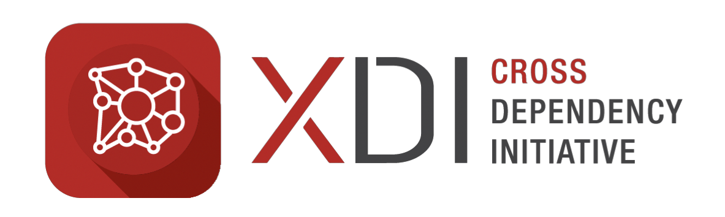

MEDIA RELEASE

EMBARGO FEB 7

XDI Convenes International Forum to streamline data-links between climate models, engineering and financial analysis

In conjunction with the 25th AMOS –ICSHMO Conference, The Cross Dependency Initiative (XDI) will convene the Roundtable for Infrastructure and Climate Change, bringing together scientists and utility decision makers to discuss climate data standards.

Taglined “Fixing the Climate Change Rail Gauge”, this roundtable brings together some of the world’s best climate scientists with industry decision makers from infrastructure, Government, finance, and legal organisations, to discuss the urgent challenge of synchronising climate modelling data with engineering and financial decision support systems used in industry and government.

With different states using different climate modelling parameters and settings, the current situation is comparable to pre-federation colonial Australia, when different states chose different rail-track spacings, resulting in the inability to run trains across state borders.

The results of the roundtable will be used to create a set of working guidelines to streamline the connection between climate modellers and industry, and to make the work of scientists ready to use for real life decision makers.

Rohan Hamden, Director of Projects at XDI said, “Regulators have asked the global financial markets to disclose their climate risks, but there is no standard defining how to choose and use climate information. This Roundtable starts a critical conversation between science and business for the future.”

The Infrastructure and Climate Change Roundtable leverages the gathering of the world’s leading scientists at the AMOS –ICSHMO conference at UNSW. The conference is the most important convenor of climate change scientists in the Southern Hemisphere, with representatives from over 50 countries covering Europe, the Americas, Asia and the Pacific.

Dr Karl Mallon, Director of Science and Systems at XDI said “A consistent approach to climate data model outputs will help ensure Australia’s buildings and infrastructure are correctly designed for flooding, bushfire and extreme windstorms. Millions of dollars are being spent right now on high quality, high resolution climate data. With an agreed approach on paramaters, we can dramatically increase the accessability of this analysis.”

XDI is Australia’s leading private sector user of climate modelling data. XDI uses massive processing engines to turn this data into engineering design specifications and financial analysis data for investors and asset managers.

“Climate litigation is heating up in Australia and the world”, said Sarah Barker, Special Counsel with Minter Ellison. “I will be joining leading industry figures from banks, insurers and utilities to present urgent, real-world issues that need to be considered by some of the worlds’ leading climate scientists”.

The outcomes of the roundtable will be published and distributed to climate scientists and industry experts around the world. They will also be incorporated into XDI’s 2018 project with the Climate Bonds Initiative in London, which will develop prototype risk and resilience standards for mitigation and adaptation projects funded by the global bond market.

The Roundtable will take place at UNSW, Kensington, on Feb 7 from 2-5pm.

FOR MORE INFORMATION CALL ROHAN HAMDEN 0422 394 679 OR RUTH TEDDER 0405 505 855

